Control File

1-Help Menu
# Source: ScreenShot Source: Provided by: [Persons Table -> ID Column: 1, Name_En Column: Motasem Essam] -> Tool: [Automation Table -> ID Column: 16, Name_En Column: Screen Capture] -> From [Operating System: Windows] on [5/27/2026]
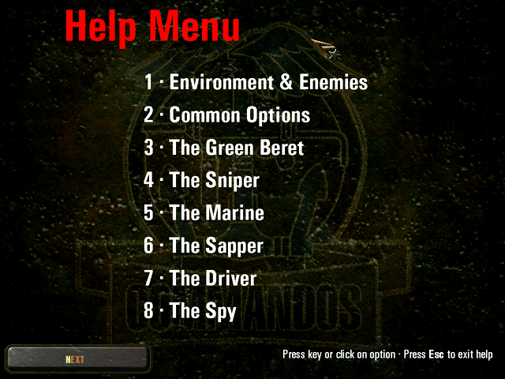

2-Environment & Enemies
# Source: ScreenShot Source: Provided by: [Persons Table -> ID Column: 1, Name_En Column: Motasem Essam] -> Tool: [Automation Table -> ID Column: 16, Name_En Column: Screen Capture] -> From [Operating System: Windows] on [5/27/2026]
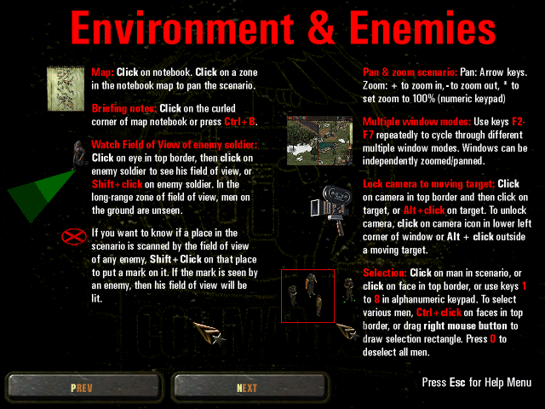

3-Common Actions
# Source: ScreenShot Source: Provided by: [Persons Table -> ID Column: 1, Name_En Column: Motasem Essam] -> Tool: [Automation Table -> ID Column: 16, Name_En Column: Screen Capture] -> From [Operating System: Windows] on [5/27/2026]
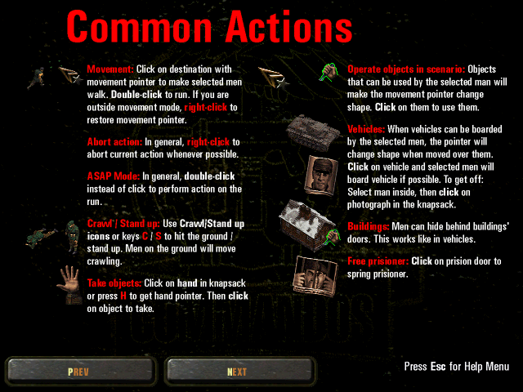

4-The Green Beret
# Source: ScreenShot Source: Provided by: [Persons Table -> ID Column: 1, Name_En Column: Motasem Essam] -> Tool: [Automation Table -> ID Column: 16, Name_En Column: Screen Capture] -> From [Operating System: Windows] on [5/27/2026]
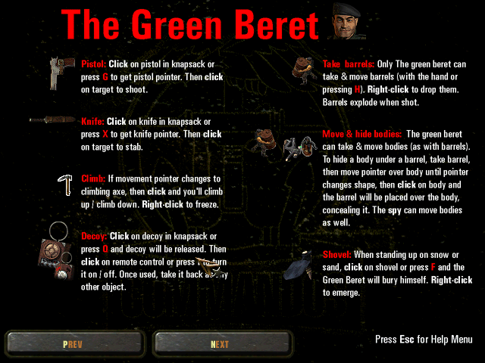

5-The Sniper
# Source: ScreenShot Source: Provided by: [Persons Table -> ID Column: 1, Name_En Column: Motasem Essam] -> Tool: [Automation Table -> ID Column: 16, Name_En Column: Screen Capture] -> From [Operating System: Windows] on [5/27/2026]
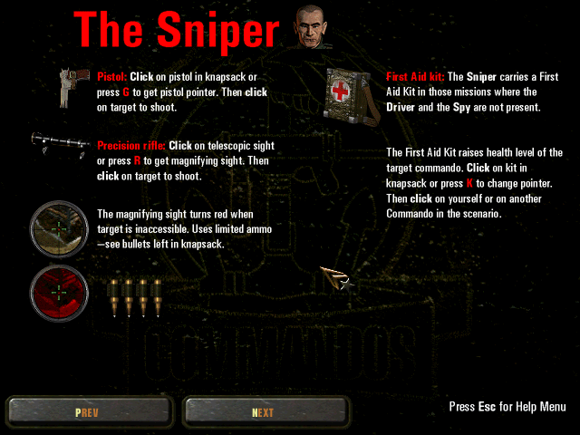

6-The Marine
# Source: ScreenShot Source: Provided by: [Persons Table -> ID Column: 1, Name_En Column: Motasem Essam] -> Tool: [Automation Table -> ID Column: 16, Name_En Column: Screen Capture] -> From [Operating System: Windows] on [5/27/2026]
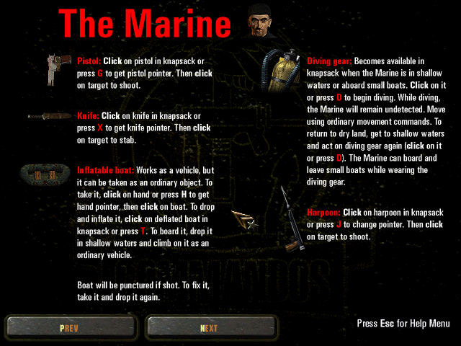

7-The Sapper
# Source: ScreenShot Source: Provided by: [Persons Table -> ID Column: 1, Name_En Column: Motasem Essam] -> Tool: [Automation Table -> ID Column: 16, Name_En Column: Screen Capture] -> From [Operating System: Windows] on [5/27/2026]
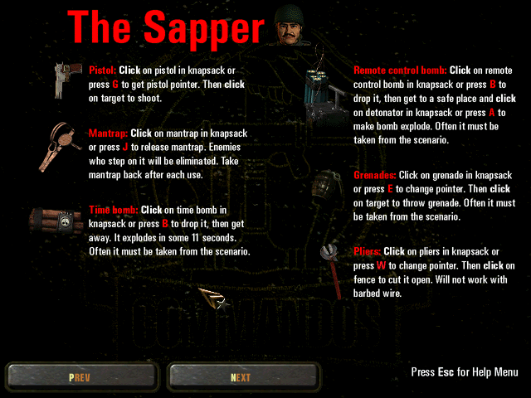

8-The Driver
# Source: ScreenShot Source: Provided by: [Persons Table -> ID Column: 1, Name_En Column: Motasem Essam] -> Tool: [Automation Table -> ID Column: 16, Name_En Column: Screen Capture] -> From [Operating System: Windows] on [5/27/2026]
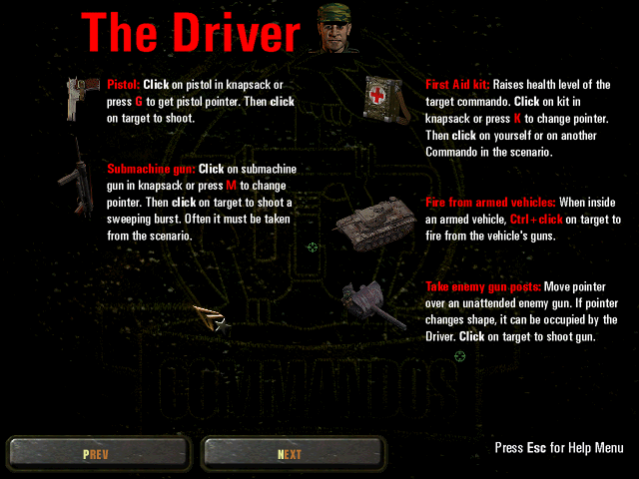

9-The Spy
# Source: ScreenShot Source: Provided by: [Persons Table -> ID Column: 1, Name_En Column: Motasem Essam] -> Tool: [Automation Table -> ID Column: 16, Name_En Column: Screen Capture] -> From [Operating System: Windows] on [5/27/2026]
